Temasek Polytechnic
School of Informatics & IT
Diploma in Applied Artificial Intelligence
Robotic Process Automation (CAI2C01)
AY2026/2027 April Semester

Proposal

Student Name :Syed Ghazi Bin Syed Muhammad Shafeeq Alsagoff

Student Admin No. : 2504242E

Tutorial Group : P02
Jenny LING (TP)
Tutor : Mdm Shuyun Chen

Submission Date : 28/5/2026

Robot Name
Home Of Primary Envisage (HOPE)
Business Domain
Healthcare Administration
Healthcare administration is involved mainly on the management of operational and administrative tasks done in medical centres like hospitals and clinics. The robot will mostly be handling on the more repetitive tasks like the handling of patient registration, entering patient data, the scheduling of appointments, generating medical reports, email notifications, and the administrative reporting for clinics or healthcare centres. I’ve chosen to target these tasks not only because they are repetitive, but also because they are time consuming and are prone to human error due to the handling and logging of large volumes of patient information. The robot will help to make these tasks automatic.
Target Department/Users
The people that are going to be using this app include the administrative staff at both hospitals and clinics, together along with their respective receptionists. The robot will also be assisting those in the Medical Records Department and the team responsible for scheduling appointments. Clinic managers will also be affected as well. The robot will benefit them as it will allow these staff to focus more on serving the patients and the more urgent healthcare operations rather than the more repetitive manual tasks that they must do daily.

Project Scope
The robot will automate processes like, the registering of patients and entering their data into the system. It will also help to schedule appointments and generate medical reports, as well as the sending of confirmation emails and reminders. There will also be daily appointment summary reporting together along with error logging and exception handling. The robot will be interacting and making use of four main applications. Excel, Outlook, Web browser, and Microsoft Word.

Main Robot Functions
Patient Registration | The robot will process new patient registration details from a web form or a pdf registration form  The robot will extract details like:  - Patient Name  - NRIC or passport number  - Date of Birth  - Contact Number  - Email Address  - Home Address  - Emergency contact  - Requested Appointment date  - Appointment type  H.O.P.E will then save the patient information into an excel database,
Patient data entry | H.O.P.E will update the records with new administrative or medical information when it comes to existing patients.  Examples of updates will include:  - Date of last visit  - Appointment type  - Assigned doctor  - Medical report status  - Follow-up appointment  - Remarks left by clinic staff  This shows that H.O.P.E does not only create new records but also maintains existing patient records.
Appointment Scheduling | H.O.P.E will check for available appointment slots from an excel appointment schedule or web-based appointment portal.  The robot will:  - Read the patients preferred appointment date  - Check available slots  - Assign the earliest available slot  - Update the appointment schedule  - Mark the slot as booked  - Save the appointment details into the patient record
Medical Report Generation | A simple medical summary report using Microsoft Word will be generated by the robot.  The report may include:  - Patient ID  - Patient Name  - Appointment date  - Assigned doctor  - Appointment type  - Medical report status  - Follow-up instructions  After generating the Word Document, the robot can export or save it as a PDF File.
Email Confirmation | H.O.P.E will use Outlook to send an appointment confirmation email to the patient.  The email will include:  - Patient Name  - Appointment date  - Appointment time  - Clinic location  - Assigned doctor  - Reminder instructions  The robot will ensure the details in the email are personalised using extracted patient data.
Daily Appointment Summary report | The robot will generate a daily report at the end of the process.  The report will include:  - Total appointments scheduled  - Number of new patients  - Number of returning patients  - Cancelled or failed cases  - Missing information cases  - Successfully processed records  This report will be saved in Excel and can also be emailed to the clinic manager.

Justification
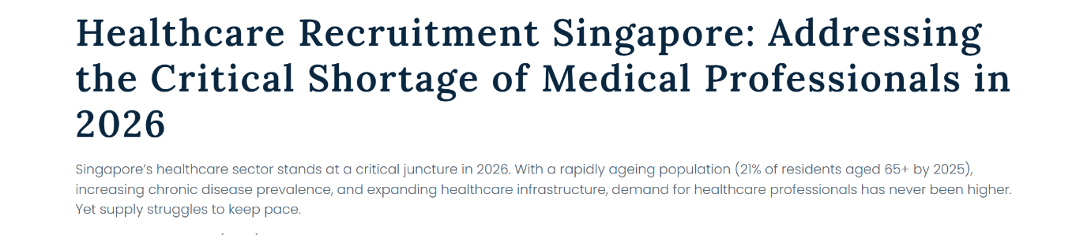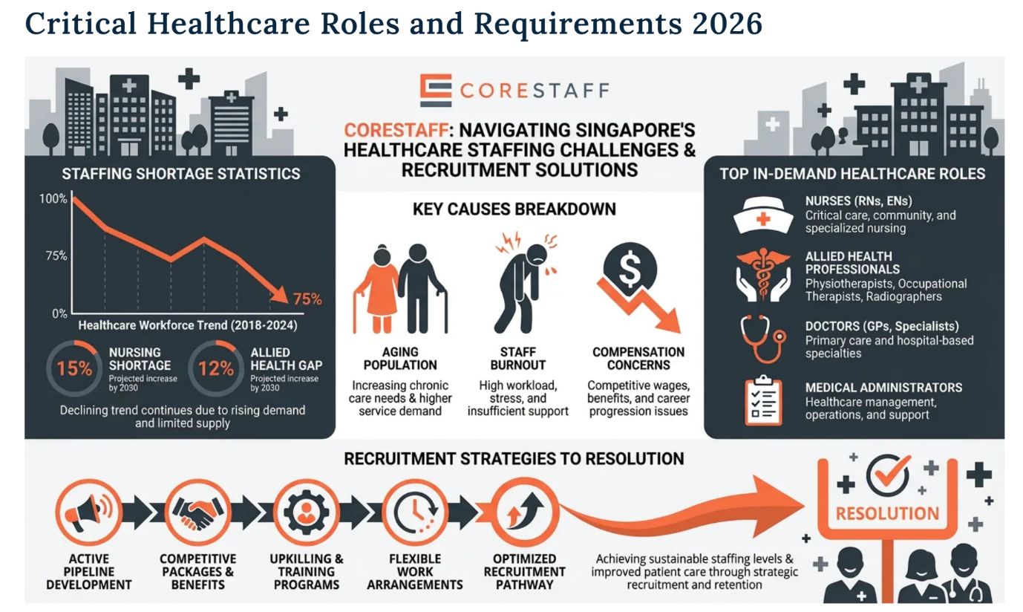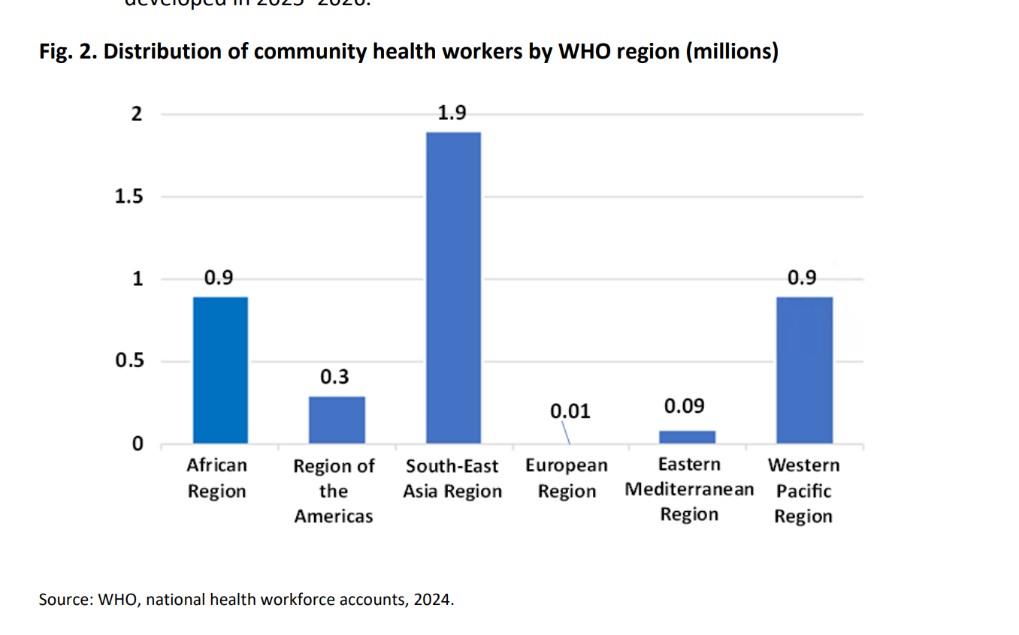
Globally, hospitals are facing a crisis with understaffing, driven by an aging population, workforce burnout, and early retirements. The World Health Organisation projects a global shortage of over 11 million healthcare workers. In Singapore, the Ministry of Health faces vacancy rates of 12%for registered nurses and requires 15,000 additional healthcare professionals by 2030. Understaffing could lead to a variety of errors, one of which include Medical Errors, whereby Nurses working short-staffed experience higher rates of mental fatigue, which compromises clinical judgement. Despite the number of hospital staff increasing, so does the demand for such workers. I believe my robot will help with this. For one, it will be removing a huge chunk of labour from the hands of the nurses which would help to alleviate the mental fatigue. This may also close some of the gaps in the workforce as it transforms one of the roles of a nurse into a more automated process, thus allowing them to dedicate more time into caring for patients in their care.
Need for automation
Healthcare administrative staff often handle a large number of patient records and appointment requests. When this is done manually, staff may spend a lot of time copying information between forms, spreadsheets, emails, and scheduling systems.
Manual processing can cause problems like inputting incorrect patient details, the duplication of patient records, missing appointment requests, and delayed confirmation emails. It may also lead to the poor tracking of daily appointments and an increased workload for reception staff. Automation is needed to reduce repetitive data entry and improve the reliability of the healthcare administrative process.
Value of automation
The robot will provide value in the following ways:
Improves Productivity | The robot can process registration forms, update records, schedule appointments, and send emails faster than manual processing.
Reduces Human Error | The robot can validate required fields and check for missing or duplicate patient details before updating records.
Improves Patient Experience | Patients can receive confirmation emails faster, reducing uncertainty about their appointment details.
Improves Record Accuracy | Patient and appointment records are updated consistently in Excel and generated reports.
Supports Better Management Reporting | The daily appointment summary allows clinic managers to track workload and appointment status more easily.

How does it improve productivity?
The Home Of Primary Envisage (HOPE) will improve productivity by automating the more time-consuming administrative tasks like patient registration, patient data entry, appointment scheduling, report generation, and email confirmation. Without the automation, the hospital/ clinic staff will have to manually open each form, read patient details, type the information into Excel, check appointment slots, prepare reports, and send emails one by one. This is extremely time consuming, especially when many patients register in a day. With HOPE, these steps can be completed automatically in one continuous process.

Task | Manual Process | Automated Process
Patient registration | Staff manually reads and types patient details | Robot extracts and enters patient details automatically
Patient data entry | Staff updates records one by one | Robot updates Excel records automatically
Appointment scheduling | Staff checks available slots manually | Robot finds and assigns available slots
Medical report generation | Staff prepares Word/PDF reports manually | Robot generates reports using a template
Email confirmation | Staff writes and sends emails manually | Robot sends personalised Outlook emails automatically
Daily report | Staff counts and prepares summary manually | Robot generates daily summary automatically

The robot will allow the healthcare staff to process more patient registrations and appointments in a shorter time, while also reducing errors and freeing staff to focus on patient service.
Robot Category
Unattended
The robot is designed as an unattended robot because it can run automatically at scheduled times. It will do things like process new patient registrations every morning, check for new appointment requests every hour, and generate appointment reports at the end of the day.

Current Scenario
- Patient submits a registration form through PDF or online form
- Clinic staff manually opens the form
- Staff reads the patient’s personal details
- Staff manually enters the details into excel
- Staff checks whether the patient already exists
- Staff searches for available appointment slots
- Staff manually updates the appointment schedule
- Staff creates or updates patient record
- Staff manually prepares a medical summary or appointment document
- Staff writes a confirmation email
- Staff sends email to the patient
- Staff updates the daily appointment report manually
- Staff repeats the process for every patient
Automation Scenario
- H.O.P.E opens the patient registration source from PDF or web browser
- H.O.P.E extracts patient details
- H.O.P.E validates required fields
- H.O.P.E Checks whether patient already exists in Excel
- If the patient is new, the robot creates a new patient record
- If the patient already exists, the robot updates the existing record
- Robot checks appointment availability
- Robot assigns an appointment slot
- Robot updates the appointment schedule
- Robot generates a Word medical summary report
- Robot saves or exports the report as PDF
- Robot sends a personalised Outlook confirmation email
- Robot updates the daily appointment summary report
- Robot records successful and failed transactions in an error log.
Process Flow Chart
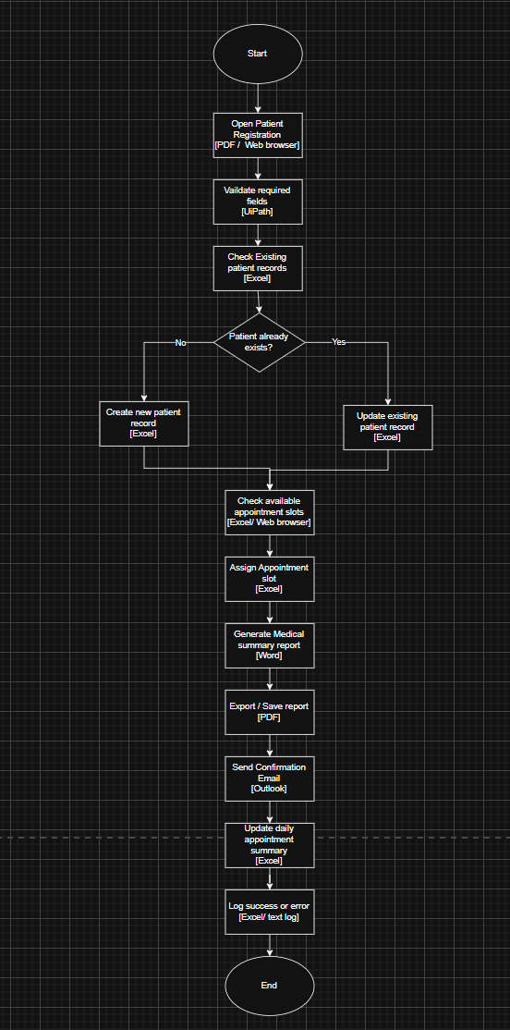
References
Leuchter, R. K., Delarmente, B. A., Vangala, S., Tsugawa, Y., & Sarkisian, C. A. (2025). Health care staffing shortages and potential national hospital bed shortage. JAMA Network Open, 8(2), e2460645. https://doi.org/10.1001/jamanetworkopen.2024.60645

Corestaff Pte Ltd. (2026, January 26). Healthcare Recruitment Singapore: Addressing the critical shortage of medical professionals in 2026. https://www.corestaff.com.sg/healthcare-recruitment-singapore-medical-talent-shortage/

Executive Board, & Director-General. (2024). Global strategy on human resources for health: workforce 2030. https://apps.who.int/gb/ebwha/pdf_files/EB156/B156_15-en.pdf

HEALTHCARE MANPOWER DEMAND. (n.d.). Ministry of Health. https://www.moh.gov.sg/newsroom/healthcare-manpower-demand/

CURRENT HEALTHCARE WORKFORCE STRENGTH COMPARED AGAINST PROJECTED SERVICE DEMAND. (n.d.). Ministry of Health. https://www.moh.gov.sg/newsroom/current-healthcare-workforce-strength-compared-against-projected-service-demand/

Health Manpower. (n.d.). Ministry of Health. https://www.moh.gov.sg/others/resources-and-statistics/health-manpower/

